# Crime Data Analysis

Dataset: crime_incidents_2013.csv

## How many offenses were there in 2013?

## How many crimes were committed in each offense?

## How many different methods were used (And their count) in offense “Homicide”

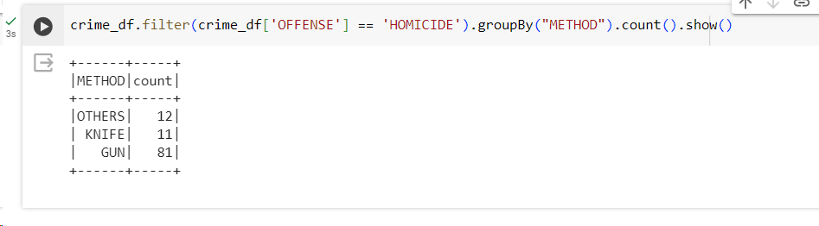

## Which shift had the maximum crimes?

